

**and**

**NAME: _________________________________ Spring Term 2017**

**School: ___________________________________ Class: _______________**



**‘Voices for Freedom’**

**Date: Friday 10th March**

**Venue: Chichester Cathedral**

* Bring your song lyrics and a pencil with you!
* Bring any medication / glasses with you.
* Bring a packed lunch in a disposable bag
* You need to wear smart school uniform
* A coach will take you to the event.
* Your parents will bring you home / or arrange transport home for you
* The cathedral opens to parents / the audience at 3.30pm.
* Siblings from either school can be picked up at 2.15pm
* Performance to parents / siblings / grandparents / friends is: 3.45 – 4.15pm

**A message from Mrs Kear**

What an amazing opportunity for you – to sing in Chichester Cathedral at such a young age! We are really looking forward to working with you on this event! We hope that you have a lot of fun working towards this performance, and that you really enjoy the whole challenge.

Sing your hearts out!

**Contents:**

1. Dona Nobis Pacem

2. Freedom!

3. Wayfaring Stranger

4. No Wars Will Stop Us Singing

5. I Wish I Knew How It Would Feel To Be Free

6. Long Since In Egypt’s Plenteous Land

**‘Dona nobis pacem’**

(Latin for ‘Give Us Peace’)

1. Sing in unison

2. Sing in three-part canon

Dona nobis pacem, pacem.

Dona nobis pacem.

Dona nobis pacem.

Dona nobis pacem.

Do-na nobis pacem.

Dona nobis pacem.

**Freedom! – Zimbabwean Chant** (adapted by Patrick Allen)

In 4 part harmony

Descant – lead part:

Free-dom, oh free-dom, oh freedom,

Freedom is coming , oh yes I…(repeat)

Soprano:

Freedom is coming, freedom is coming,

Freedom is coming, oh yes I know…(repeat)

Oh yes I

Alto - melody:

Freedom is coming, freedom is coming

Freedom is coming, oh yes I know…(repeat)

Oh yes I

(Tenor X)

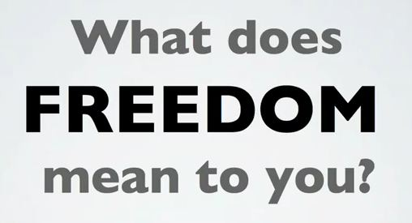

Bass:

Freedom is coming, freedom is coming

Freedom is coming, oh yes I know…(repeat)

Oh yes I …

**Wayfaring Stranger**

Beatbox (simplified):

B t B t B t – B 7 t

Body percussion:

Chest click click chest chest click click chest chest click click chest

Vocal harmony:

Mm - -, M-m – (repeatedly throughout verse)

**Verse 1 vocals:**

I am a poor way-far-ing stran-ger,

Trav’ling through this world a-lone.

Yet there’s no sickness, no toil, no danger

In that bright land to which I go.

**Chorus:**

I’m going there to see my ***father***,

I’m going there, no more—to- roam,

I’m only go-ing over Jor-dan,

I’m only go-ing over home.

**Chorus part 2 (low) + part 3 (high):**

**Unison:** I’m going home

**In harmony:** I’m going home (x6) … no more to roam

**Unison:** Mm - -, M-m – (x4 to complete chorus + then continue in verse)

**Verse 2:**

I know dark clouds wil gather round me,

I know my way is rough and steep

But golden fields lie just be-yond me,

Where weary eyes no more will weep.

**Chorus… *mother***

**Verse 3:**

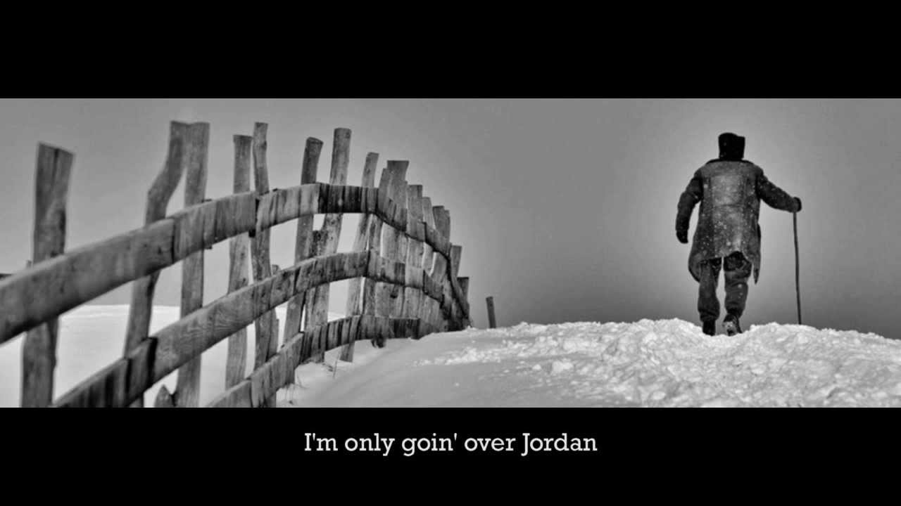I’ll soon be free from ev-ry tri—al

This form shall rest be-neath the sod.

I’ll drop the cross of self de-nial

And enter in that home with God.

**Chorus… *Saviour***

**No Wars Will Stop Us Singing**

**SJA and WP pupils to learn the main tune throughout**

**Choristers to add harmony**

Ugly sounds are overhead and the streets are coloured red.   
Young lives lost ev’ry day, it’s always been that way.   
But we believe one day we’ll see a world at peace, in harmony.   
And that is why we say

*No wars will stop us singing; our voices will stay strong.   
Even through the darkest night we will sing our song.*    
No fear will stop us dreaming; our dreams will light the sky.   
Even when all hope is gone our dreams will not die.

We are the future; we are tomorrow; we are the peace that you all crave.   
If our lives are taken we’ll sing from beyond the grave.

**MC900083047***No wars will stop us singing; our voices will stay strong.   
Even through the darkest night we will sing our song.*

We will sing, we will sing, we will sing, our song  
we must sing our song.

**I Wish I Knew How It Would Feel To Be Free**

I wish I knew how it would feel to be free.

I wish I could break all the chains holding me.

I wish I could say all the things that I should say,

Say ‘em loud, say ‘em clear, For the whole round world to hear.

I wish I could share all the love that’s in my heart.

Remove all the bars that keep us apart.

I wish you could know what it means to be me,

Then you’d see, and agree, That ev’ry man should be free.

I wish I could give like I’m longing to give.

I wish I could live like I’m longing to live.

I wish I could do all the things that I can do

And tho’ I’m way overdue, I’d be starting anew.

Well I wish I could be like a bird in the sky.

How sweet it would be if I found I could fly.

Oh I’d soar to the sun and look down at the sea,

Then I’d sing ‘cos I know how it feels to be free.

Then I’d sing ‘cos I know how it feels to be free.

Yes I’d sing ‘cos I know how it feels to be free!

**Long Since In Egypt’s Plenteous Land**

Music by CHH Parry

**Verse 1 (Cathedral choristers only)**

*Long since in Egypt’s plenteous land,*

*Our fathers were oppressed;*

*But God, whose chosen folk they were,*

*Smote those who long enslaved them there,*

*And all their woes redressed,*

*And all their woes redressed*

**Verse 2 (all children)**

The Red Sea stayed them not at all,

Nor depths of liquid green;

On either hand a mighty wall of waters

clear rose high at his call,

And they passed through between,

And they passed through between.

**Verse 3 (all children)**

In deserts wild they wandered long,

They sinned and went astray;

But yet his arm to help was strong,

He pardoned them tho’ they did wrong,

And brought them on their way,

And brought them on their way.

**Verse 4 (all children)**

At last to this good land they came,

With fruitful plenty blest;

Here glorious men won endless fame,

Here God made holy Zion’s name,

And here he gave them rest,

And here he gave them rest.

**Verse 5 (cathedral choristers sing top part; guests sing middle part)**

Oh, may we ne’er forget what he hath done,

Nor prove unmindful of his love,

That, like the constant sun,

On Israel hath shone,

And sent down blessings from above.