Welcome to William Penn

24th April 2020

Dear Parents of

I am delighted to confirm that has been allocated a place at William Penn School.

In the meantime, we do need to ask you for a variety of information. As a ‘paperless’ school, we aim to correspond electronically whenever possible. Please find attached our New Starters Pack, which we would be very grateful if you could complete and e-mail to the school office.

Whilst we would usually offer taster sessions and welcome meetings, we are not able to do this at the given time due to the current crisis. Should these events become possible, we will be back in touch.

In the meantime, the link below might be of help to you. We will also be sending you our leaflet ‘Starting School September 2020, which provides some tips for preparing your child for school.

- Help children aged 2-4 to learn at home during coronavirus (COVID-19) - Advice for parents and carers of children who have not yet started school.

If your child currently attends a nursery, it would be helpful if you could let us know which one and provide a contact so that our Year R class teacher can make contact prior your child starting school at William Penn School.

We would also like to ensure that you are on our newsletter distribution list so that you are up to date with news from William Penn in advance of your child starting school. Please would you confirm to office@williampenn.co.uk that you do not object to being added to this distribution list.

If you do have any questions at this stage, please don’t hesitate to email Mrs Stephenson in the school office on the above email address.

We look forward to welcoming .

Yours sincerely

Stephen Kear

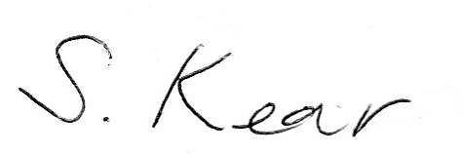

Headteacher

