1. ‘The Thank You Song’ (Harvest Song)

When our plates are piled up high,
Or we’ve nearly scraped them dry!
Oh, when our cupboards overflow,
And in our gardens, apples grow…
Chorus:
Oh, help us not to forget,
Remind us not to forget:
We’ve all we need, and more
And so we should make sure
That our hearts say “Thank You!”
That our lips say “Thank you!”
That our prayers say “Thank You for our food!”
That our hearts say “Thank You!”
That our lips say “Thank you!”
That our prayers say “Thank You for our food!”
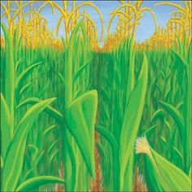
When we see the ‘fields of gold’,
Corn soon ready to be sold;
Or when the shops say ‘three for two!’
There’s more for me and more for you…

Chorus… – see above
Father we thank You for our food!
Thank You for stores of all things good!
Help us to learn to share it like we should…
Oh…
Thank You for warmth and sun and rain!
Thank You for fields which give us grain!
Thank You for blessing harvest-time again!
(Repeat this section)

