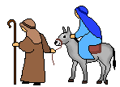
2. Mary and Joseph’s Song

Duet – Mary + Joseph
1. We had to travel to Bethlehem,
To the land that was our home.
Many a mile there to Bethlehem,
We must obey, we had to pay our tax to Rome.
Weary, weary, such a long way to go.
Sleepy, sleepy, but we’ll get there we know.

Group 1
2. They had to travel to Bethlehem,
To the land that was their home.
Many a mile there to Bethlehem,
They must obey, they had to pay their tax to Rome.
Weary, weary, such a long way to go.
Sleepy, sleepy, but they’ll get there they know.

Group 2 / All?
3. Nowhere to stay there in Bethlehem,
Not a welcome was in sight;
Only a stable in Bethlehem,
But what a joy, their baby boy was born that night
All? Happy, happy, at the birth of the boy.
Jesus, Jesus, little baby, their joy
Happy, happy, at the birth of their boy.
Duet – Mary + Joseph
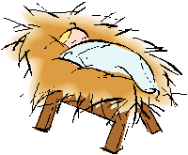
Jesus, Jesus, little baby,(pause) our joy.

