Welcome to William Penn School…
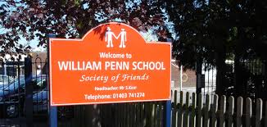

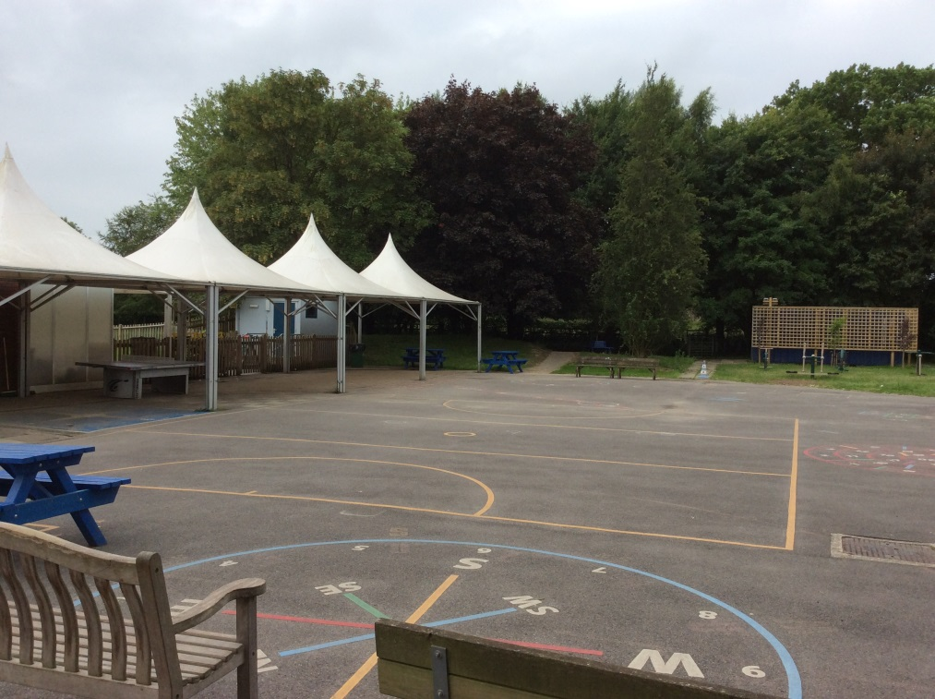
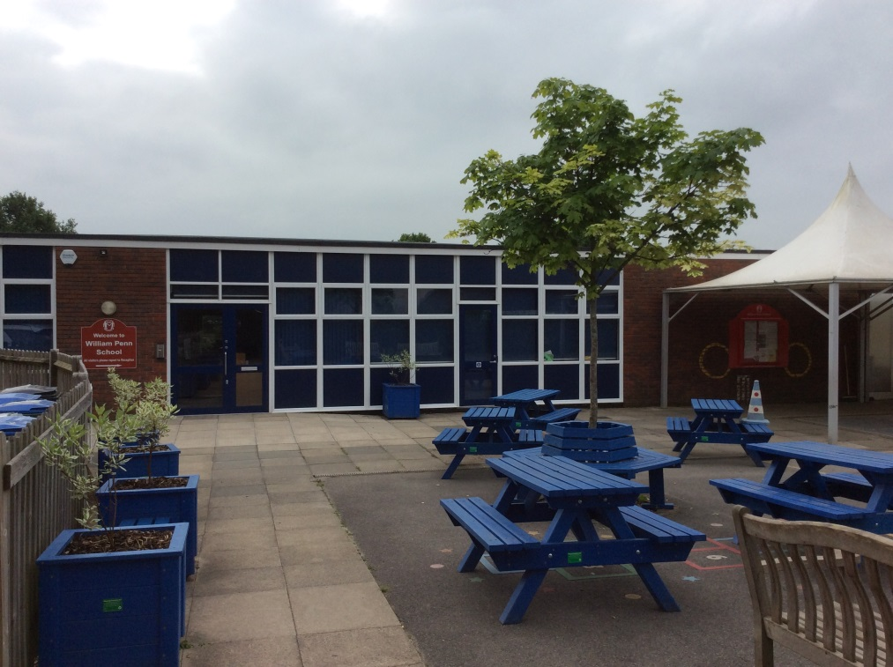
This is my new school…
This is the playground…
This is my new classroom…
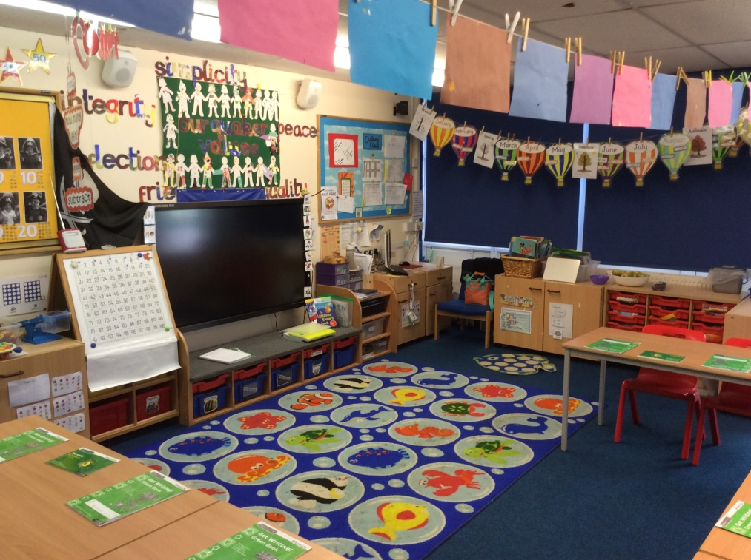
This is Cadbury class playground…
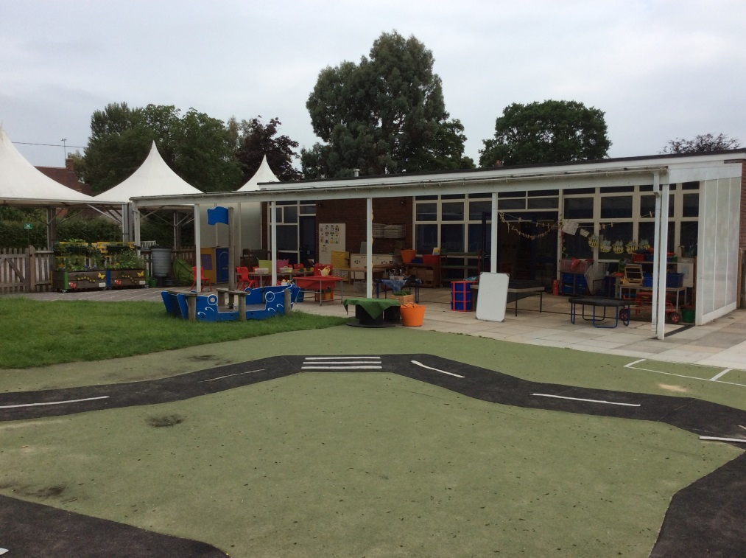
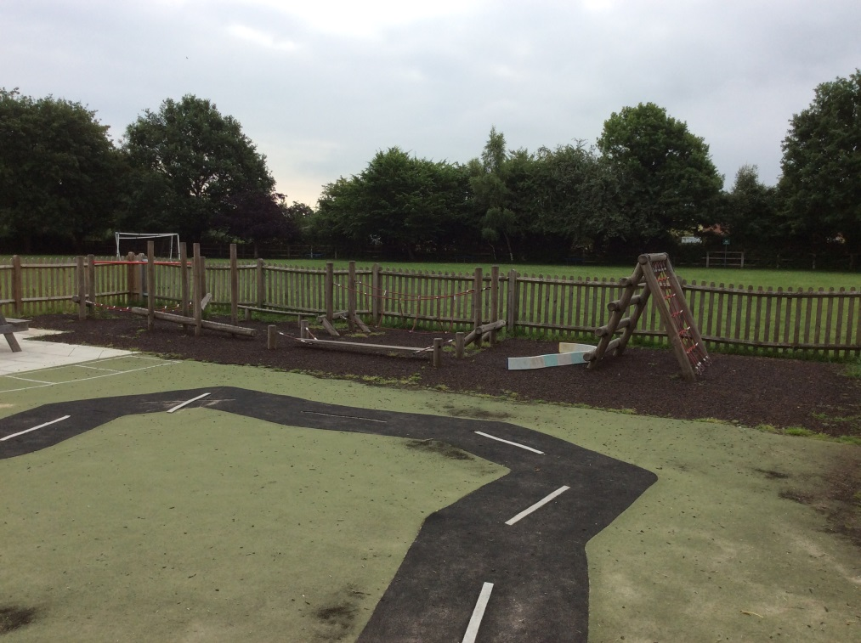
This is the field…
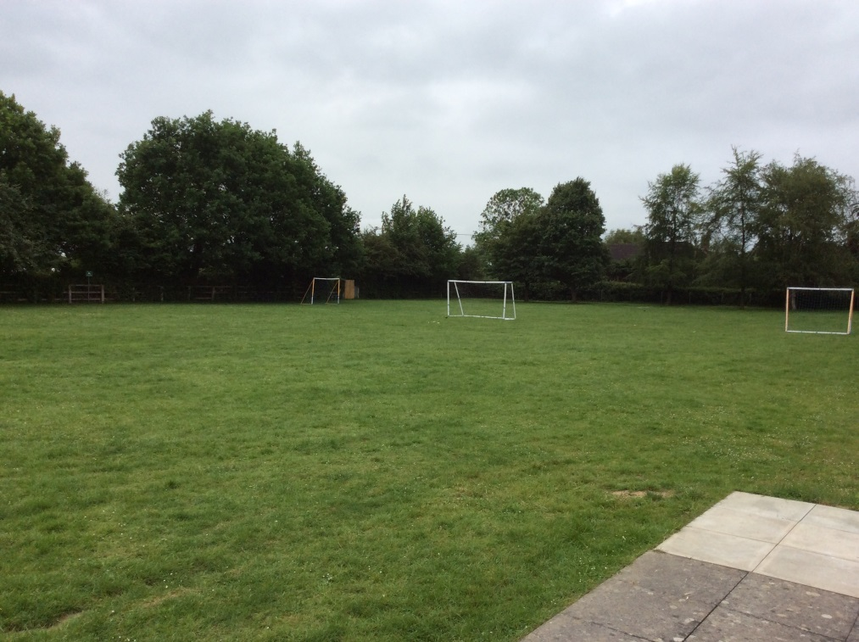
This is the trim trail...

These are some of my new teachers…

This is Mr Kear. He is the Headteacher.

This is Miss Thomas. She is the TA in Key Stage 1.

This is Miss Botha. She is your class teacher.

This is Mrs Anderson. She is the HLTA for Key Stage 1.

We look forward to seeing you in September!

