8. He Came In Love

All – Main tune
JBB – harmony

1. He came in love to bring hope to the world,
A world that had lost its way.
Left heaven’s home, came to earth a baby King
So now every Christmas we can gladly sing:

CHORUS:
Let the bells ring out,
Let the bells ring,
Let the people shout,
Let the bells ring,
Songs of joy to the King, the King of Kings REPEAT
joy to the King, the King of Kings REPEAT

Let’s be the first
Let’s be first
To share His love on earth,
To share His love on earth,
TOGETHER: For it’s Christmas time again!

2. He came in love to bring hope to the world,
He came to bring hope to the world
A world that had lost its way.
A world that lost its way
Left heaven’s home, came to earth a baby King
Left home came to earth a baby King
So now every Christmas we can gladly sing:
So now every Christmas we can gladly sing:
CHORUS…
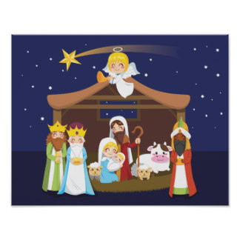
Big dramatic ending! -
Let’s be the first
Let’s be first
To share His love on earth,
To share His love on earth,
For it’s Christmas
It is Christmas,
Time a – again!
It’s that time again!

