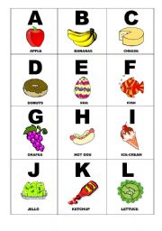
2. Alphabet Harvest
A.
Alphabet harvest from round the earth:
Each one’s different but each has worth!
Alphabet harvest from A to Z:
Are you ready? Let’s go ahead!
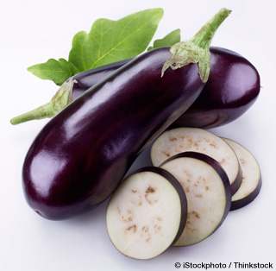
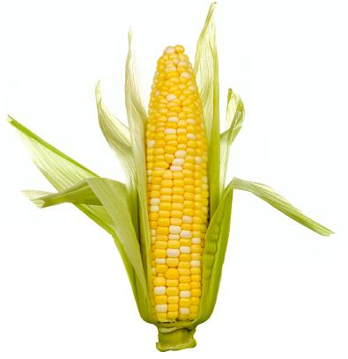
B.
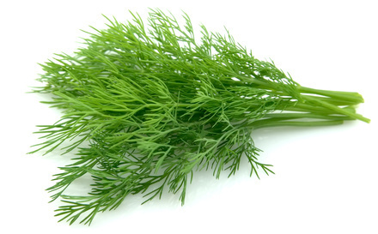
Apples, beansprouts,
Corn on the cob;
Dill and eggplant,
And flax does the job!
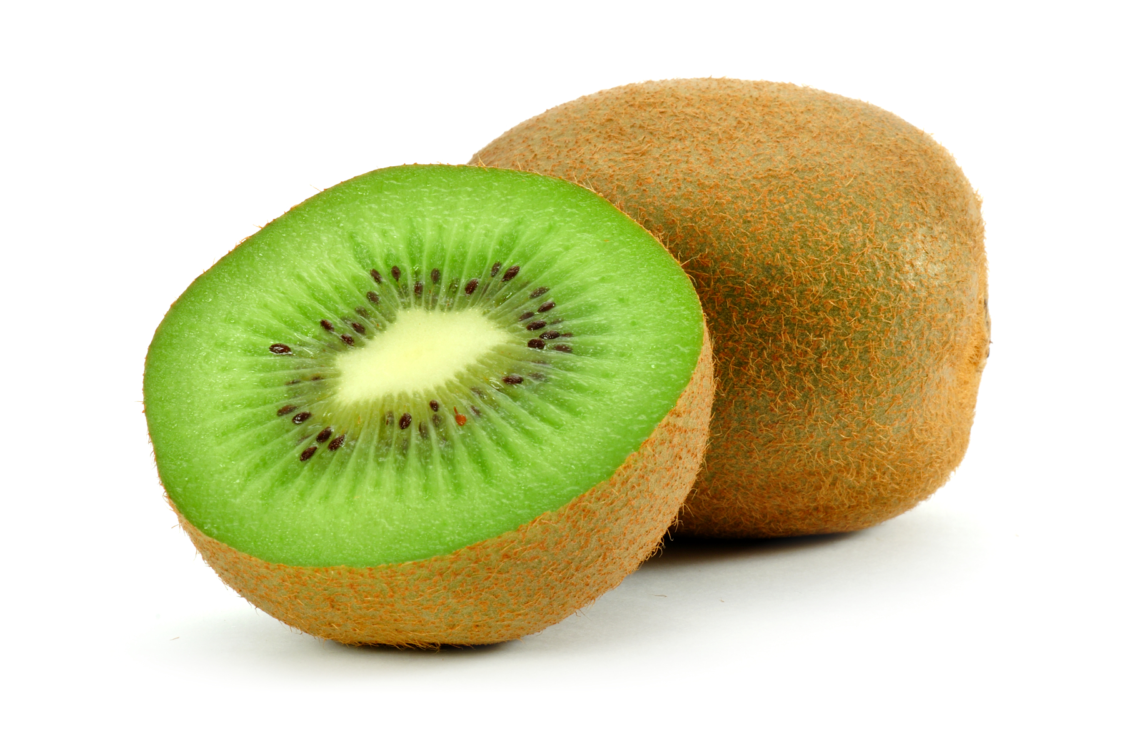
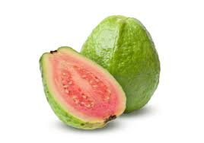
tune B.
Guava, hay,
Every Indian spice!
Jaffa orange, kiwi
And lavender: nice!
C.
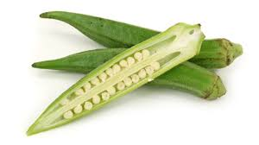
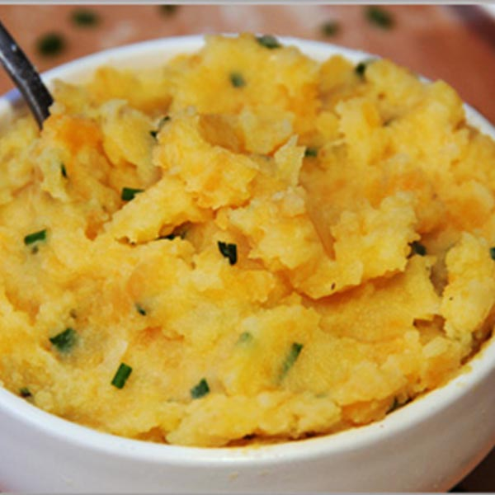
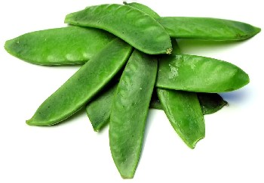
Mangetout, ‘neeps, okra
And pumpkin for pie!
Quince for jelly
And don’t forget rye!
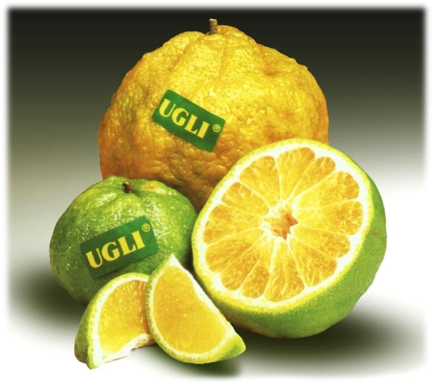
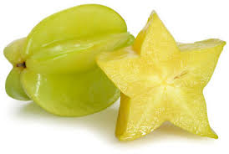
B.
Starfruit, thyme
And ugli fruit too!
Vine tomatoes, watercress:
So good for you!
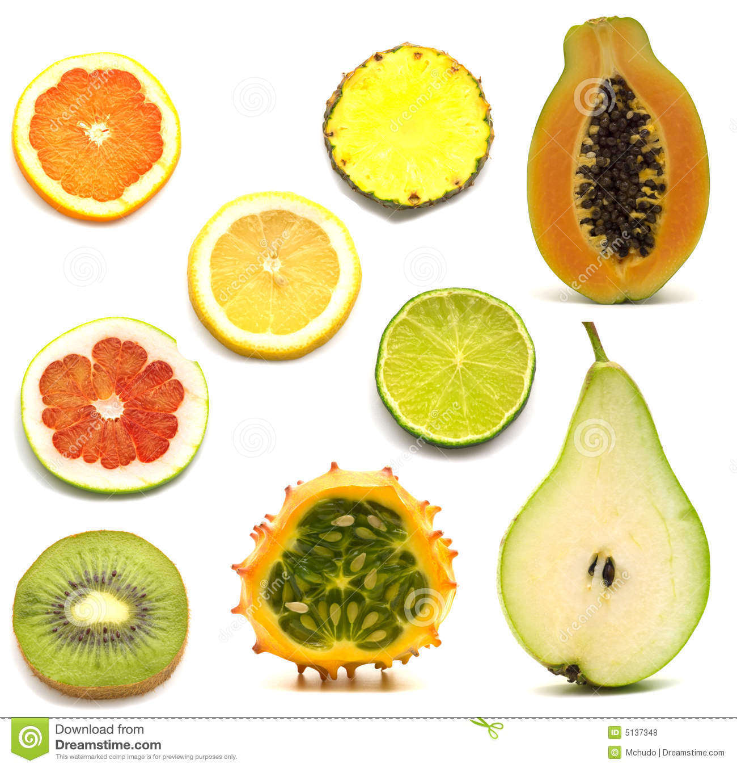
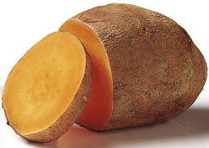
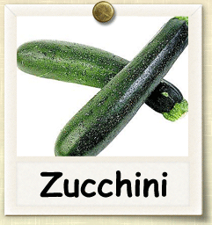
B.
X for exotic fruits?
Nice for our tea!
Yams, then finally:
Zucchini!

