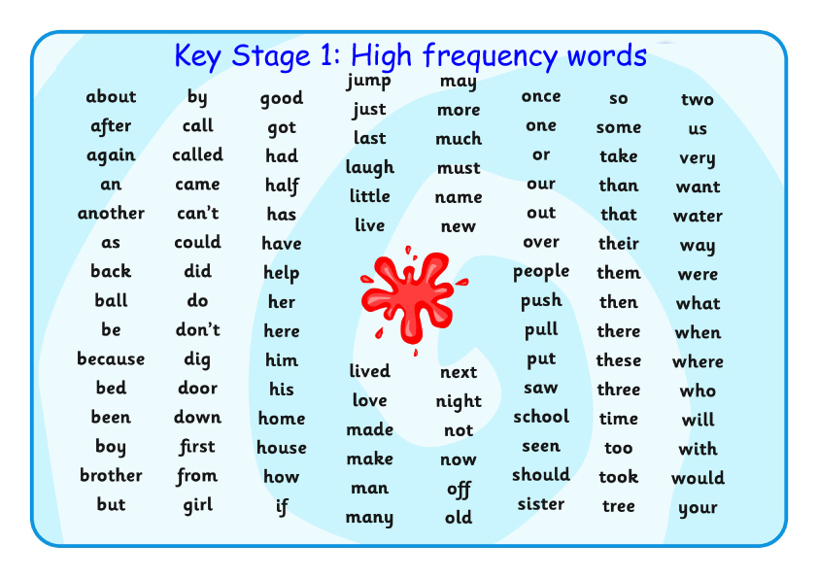
Key Stage 1: High frequency words. These spellings are a mixture of decodable words (words that can be sounded out) and tricky, exception words (words in which the English spelling code works in an unusual or uncommon way), which means the words have to be learned and recognised by sight. It is really important that children learn, not only how to read these words but also how to spell them, as they will find they will need to use them a great deal in their writing.

