

William Penn
Governors’ Newsletter – Spring 2019

You will perhaps have seen the governors as they visit the school – either when they are with the pupils and teachers, or during parents’ consultation evenings, open days and so on. It is a pleasant duty! But sometimes other commitments, outside of William Penn, mean that a governor has to give up their position here. We thank Damon Crowhurst for very willingly taking part as a parent governor at school, and are sorry that a new work opportunity has come up to deprive us of his help.

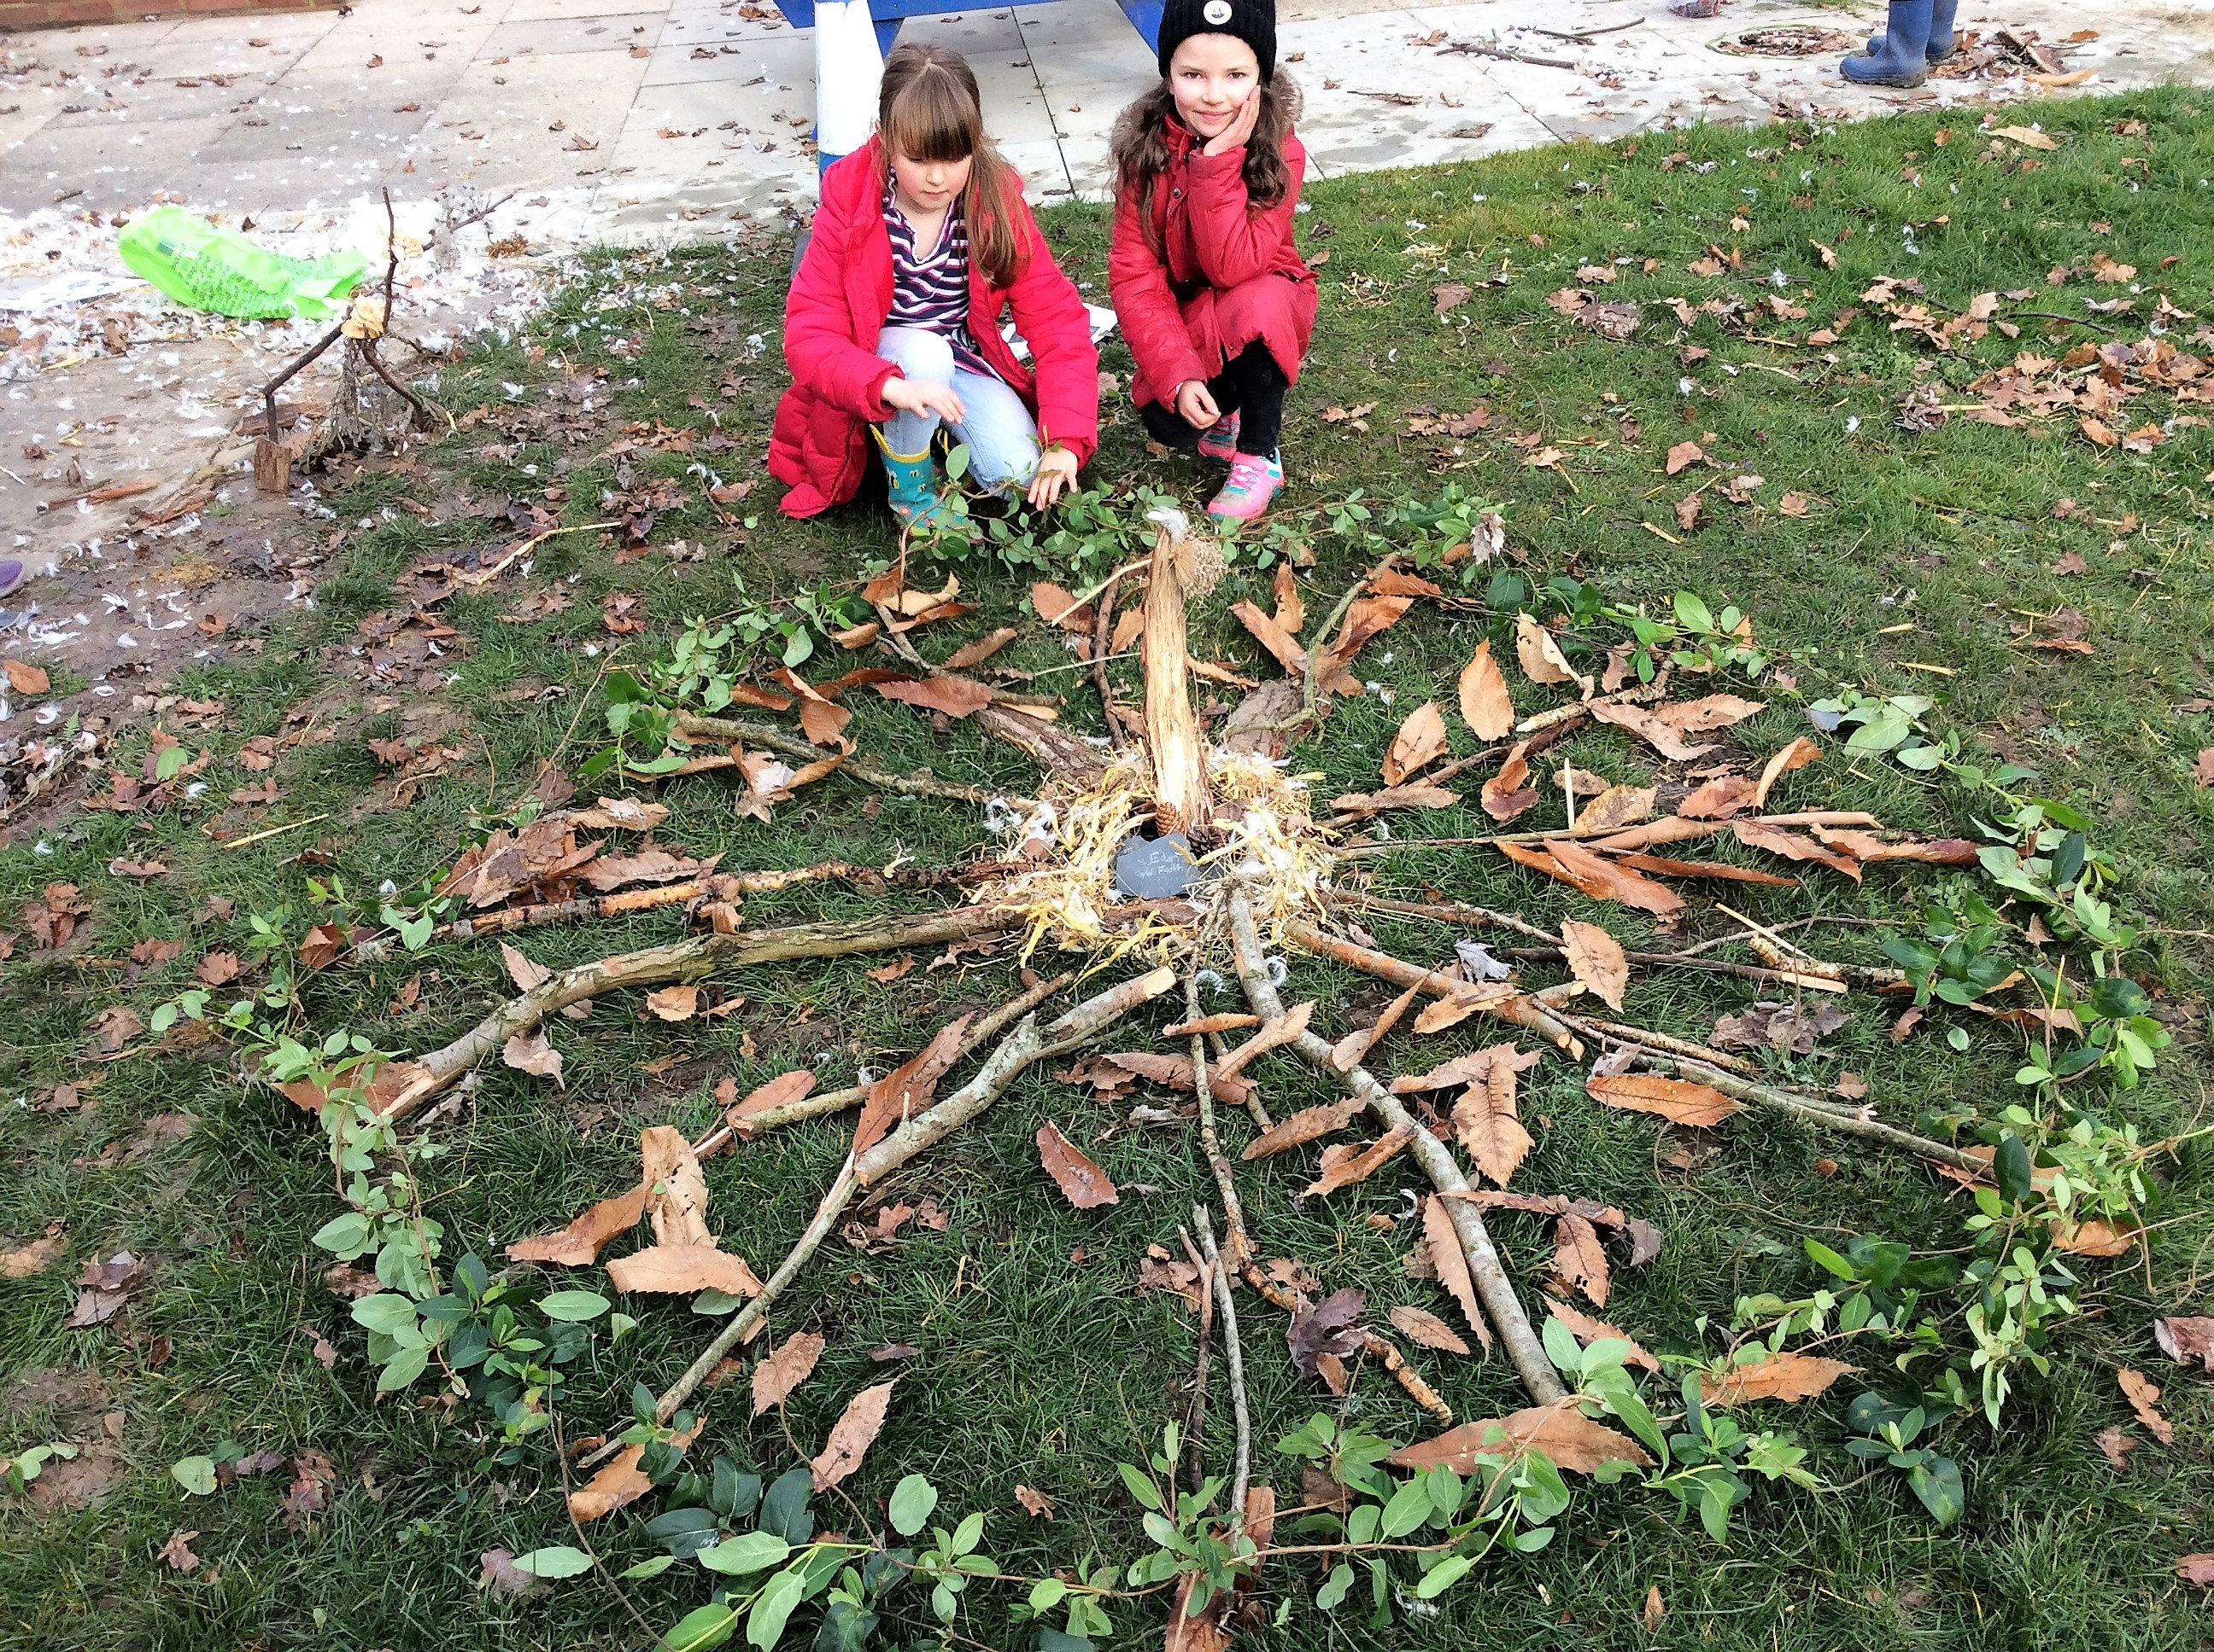
What do governors do? Our responsibility is to ensure the children at William Penn Primary School receive the very best education. Once a term, we all meet to review reports on what “Living, Laughing and Learning together” means in action. So there are reports from Mr. Kear as Headteacher, tracking how our key priorities for the children’s learning are making progress. Each governor has chosen to be on sub-committee, and that meets also once a term. At the governors’ meeting we hear from the resources committee how our premises and finances stand, currently and for the future. The curriculum committee reviews reports to check what the children are learning – the scope, depth and outcomes of it – and how teachers are delivering it and being themselves supported. We hear how those surveys that parents, teachers and children filled out, have been read and the results fed back to you. And the link governors update the courses that are available for governors – some given by West Sussex, and some that can be done at home.

Yes, training courses; there is step by step guidance for governors, to introduce the aspects of governorship that might be new to you and to support you in discharging your duties. Our chair of governors has recently been meeting others of her ilk in this locality, and they have found much in common, sharing both experiences and expertise.

As a governor you would enjoy the way that everyone contributes from their own experience, and how the result is far more than the sum of the parts. We even Laugh, as well as Live and Learn!

Su Johnston

