4. Kings’ Song
CHORUS: All – main tune
Fry class – harmony
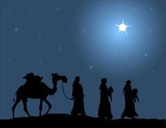
Trio / group 1?
1. Over hills and valleys
To look for a baby King;
We’ve got to find him,
Give him the gifts we bring.

CHORUS:
Main tune: All
We’ve got to follow the star, however far,
We’ve got to follow the star,
Follow the star to find where you are. REPEAT
Harmony - Fry class:
We have got to follow, however far,
We have got to follow,
Follow the star to find where you are. REPEAT

Trio / group 2?
2. Been a long time looking,
Searching the sky above
The ancient writing,
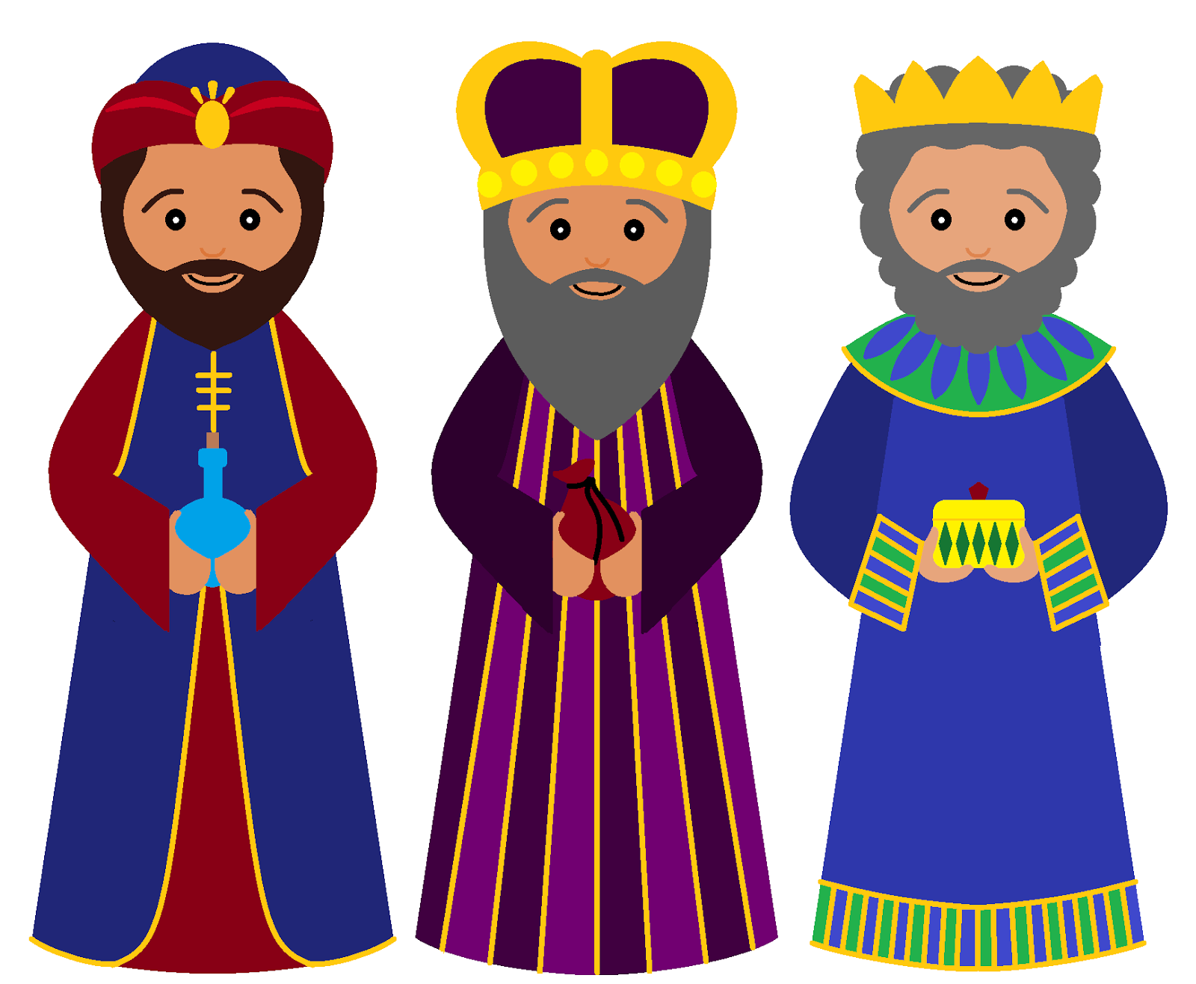
Said he would come in love

CHORUS – same as above

Trio / group 3?
3. Tiny little baby,
All of the signs will tell
The great Messiah,
Saviour of Israel.

CHORUS – same as above

