5. Shoo-wop-de-waddy-waddy!

A little bit of sun, A little bit of rain,
A shady day or two, Then start again!
(repeat)
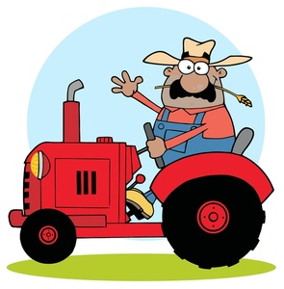
The farmer’s working hard,
And when his work is done,
He lifts his eyes to heav’n
And hopes there’ll come:

A little bit of sun, A little bit of rain,
A shady day or two, Then start again!

Shoo-wap-de-waddy-waddy,
Shoo-wap-de-waddy-waddy,
Shoo-wap-de-waddy-waddy,
Yeah, yeah, yeah!

(Lower part – yr 5/6)
Shoo-wap-de-waddy-waddy,
Shoo-wap-de-waddy-waddy,
Shoo-wap-de-waddy-waddy,

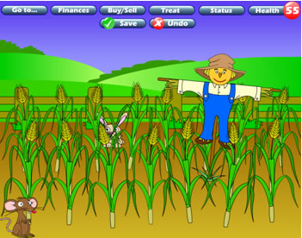
Upper part: Oo, oo…oo…oo…
All: Yeah, yeah, yeah!

The farmer ploughs the field,
The farmer sows the seeds,
The farmer feeds the soil
And kills the weeds.
(repeat)

The farmer’s working hard
And when his work is done,
He lifts his eyes to heav’n
And hopes there’ll come:

A little bit of sun, A little bit of rain,
And soon it will be harvest again

Shoo-wap-de-waddy-waddy,
Shoo-wap-de-waddy-waddy,
Shoo-wap-de-waddy-waddy,
Yeah, yeah, yeah!

(Lower part – yr 5/6)
Shoo-wap-de-waddy-waddy,
Shoo-wap-de-waddy-waddy,
Shoo-wap-de-waddy-waddy,

Upper part: Oo, oo…oo…oo…
All: Yeah, yeah, yeah!

Shoo-wap-de-waddy-waddy,
Shoo-wap-de-waddy-waddy,
Shoo-wap-de-waddy-waddy,
Yeah, yeah, yeah!

(Lower part – yr 5/6)
Shoo-wap-de-waddy-waddy,
Shoo-wap-de-waddy-waddy,
Shoo-wap-de-waddy-waddy,

Upper part: Oo, oo…oo…oo…
All: Yeah, yeah, yeah!

