Welcome to William Penn School…

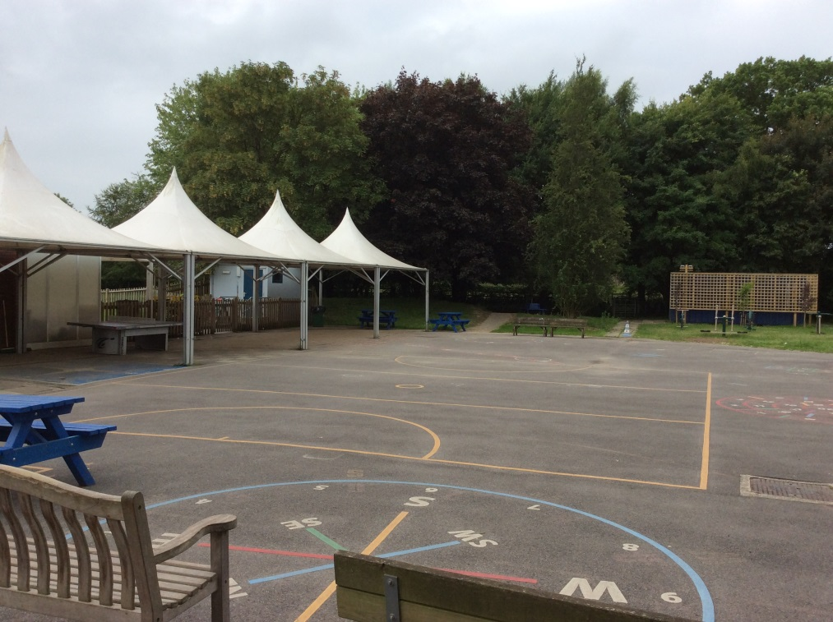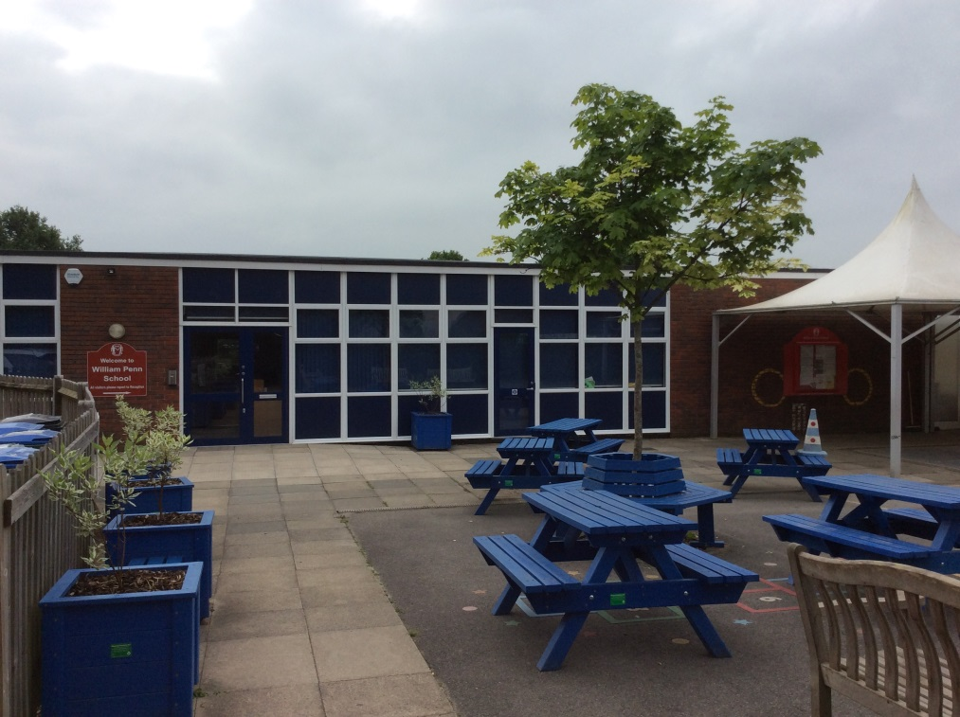This is my new school…

This is the playground…

This is my new classroom…

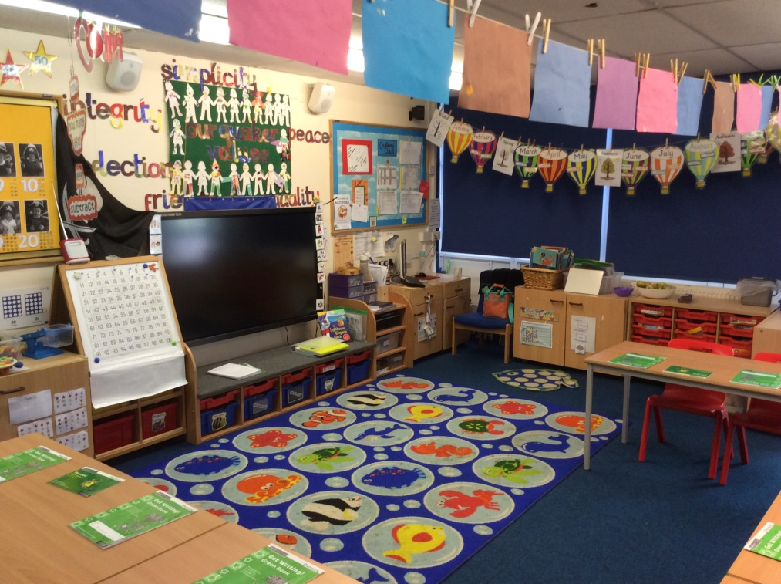

This is Cadbury class playground…

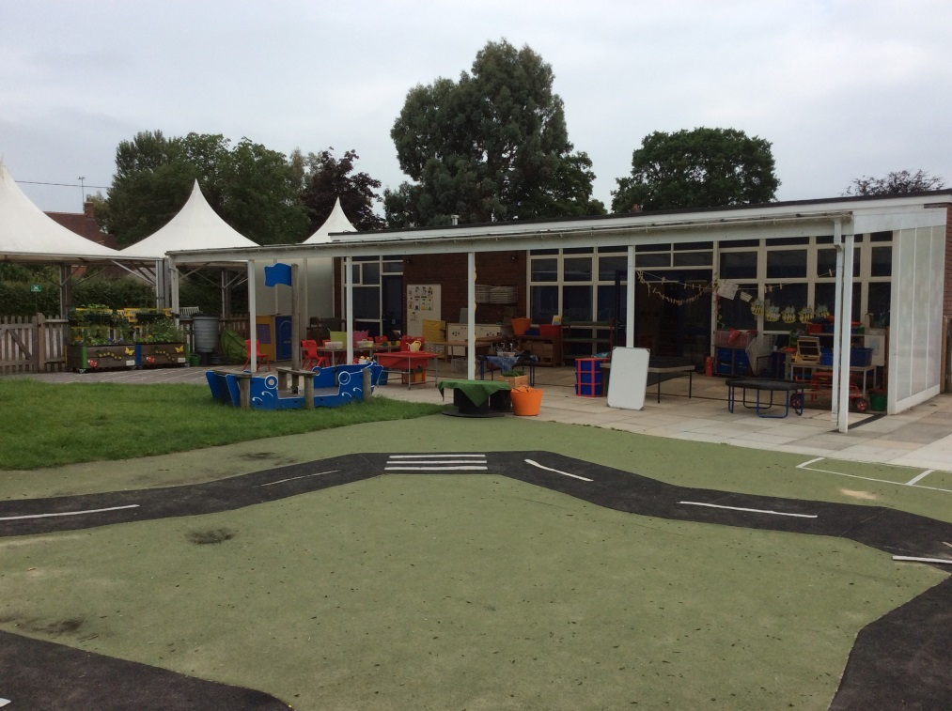

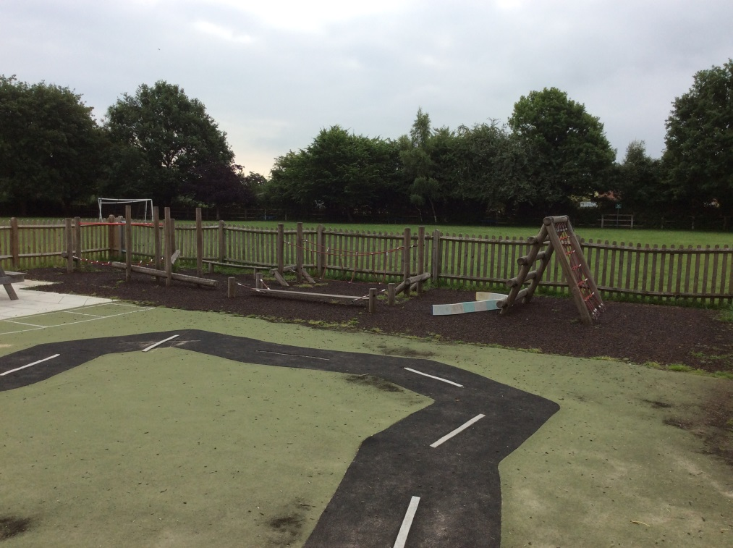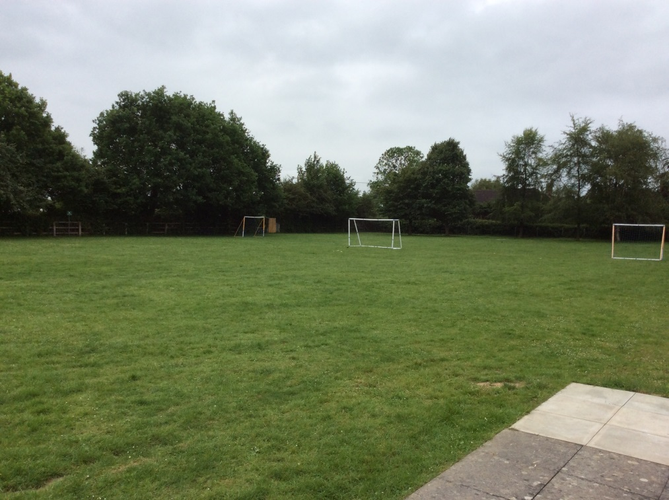This is the field…

This is the trim trail...

These are some of my new teachers…

This is Mr Kear. He is the Head Teacher.



This is Mrs Enticknap. She is your class teacher on Thursday and Friday.

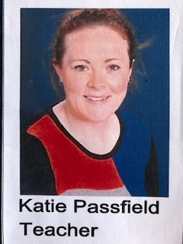

This is Ms Passfield. She is your class teacher on Monday Tuesday and Wednesday.



This is Mrs Anderson. She is the HLTA for Key Stage 1. You will see her in the afternoons.

We look forward to seeing you in September! ☺