Here are some English, Maths and Topic activities you can do at home. We are looking forward to seeing the work you complete.
Monday 29th June | English  Graphemes  https://www.bbc.co.uk/bitesize/articles/zdb3trd  Maths  Year 1 challenges  https://www.bbc.co.uk/bitesize/articles/zk3q4xs  Art  Sketch a picture of The Titanic.  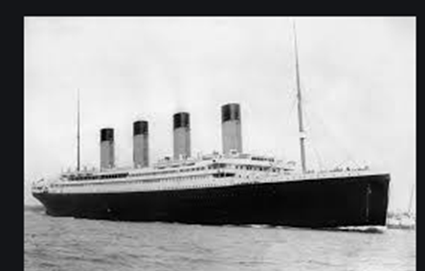
Tuesday  30th June | English  Using long ladders in writing  https://www.bbc.co.uk/bitesize/articles/zchy6g8  Maths  Grouping equally  https://www.bbc.co.uk/bitesize/articles/zm4dg7h  Geography  Find Brighton on a map and find out some interesting facts. This could include:  What are the beaches like?  What is there to do?  Why do people visit?  Can you write a ‘Did you know…?’ question.
Wednesday 24th June | English  Capital letters and days of the week  https://www.bbc.co.uk/bitesize/articles/zn7296f  Maths  Measuring Mass  https://www.bbc.co.uk/bitesize/articles/zdtq2sg  Geography  Introduction to South America - Rio De Janeiro  https://www.bbc.co.uk/bitesize/articles/z6h2mfr
Thursday 25th June | English  Book Club: The Night Box by Louise Greig  https://www.bbc.co.uk/bitesize/articles/zvrybdm  Maths  Arrays  https://www.bbc.co.uk/bitesize/articles/znwwg7h  Science  Part of the body and senses  https://www.bbc.co.uk/bitesize/articles/z8xjr2p
Friday 26th June | English  Four types of sentences  https://www.bbc.co.uk/bitesize/articles/zvp6dp3  Maths  Doubles  https://www.bbc.co.uk/bitesize/articles/zqps2v4  DT  Make your own Titanic out of junk modelling.  or  History  Can you write some facts about the Titanic?

